PREVIOUS YEAR PROBLEMS:
JEE ADVANCED 2017 problem:
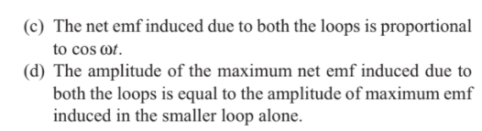
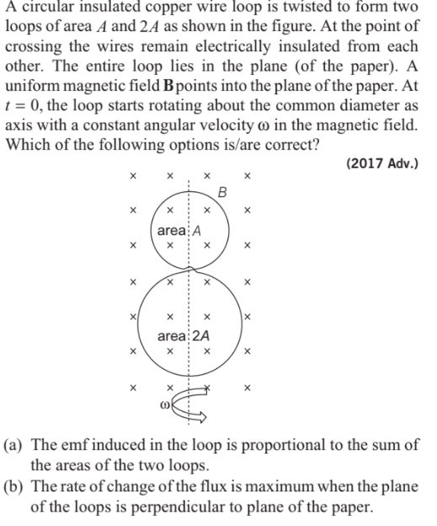

SOLUTION:
